Title – Sectors Of The Indian Economy(Chap – 2)

2016

Very Short Answer Type Questions [1 Mark]

Ques 1. Who has the ownership of the assets in the public sector?
Ans: The government of a country has the ownership of the assets in the public sector.

Ques 2. What does GDP stand for?
Ans: GDP stands for Gross Domestic Product. It is the value of all the final goods and services that are produced in a country within a particular year.

Short Answer Type Ques [3 Marks]

Ques 3. Name the sector that is the largest employer in India. Why does this sector produce only a quarter of the National GDP?
Ans: The agricultural sector (Primary) is the largest employer in India. Nearly 51% of the population is engaged in this section in one way or the other. However, its share in the national GDP is very less because of the following reasons.

- The average size of the land holdings is very low which results in low productivity per holder.
- Less use of modern technology and knowhow among the farmers to increase crop productivity.
- The systems of providing financing and marketing facilities have been insufficient since independence. The farmers are not able to get benefits fr6m the loan facilities and access to large markets.
- Absence of alternate income generating activities in rural areas give rise to disguised unemployment where efficient labour force is not used to its optimum.

Long Answer Type Ques [5 Marks]

Ques 4. How far is it correct to say that several services which cannot be provided by private sector can be provided by the public sector? Explain.
Ans: A few examples of public sector activities are Indian Railways, water, electricity board and modes of transport.
There are several necessities of common man, but it is not possible for the private sector to provide all these things at reasonable cost. For example, water and electricity are the basic needs of everyone. If the work of providing these is given to private sector then the latter can exploit this opportunity by selling the same at high rates. Therefore the supply of basic amenities is given to the government so that it provides these facilities to the people at low and affordable rates, ensuring the smooth and uninterrupted supply to the public.

2015
Short Answer Type Questions [3 Marks]

Ques 5. What constitutes the unorganized sector in urban areas? Why do workers in this area need protection?
Ans: In the urban areas, unorganised sector comprises mainly small-scale industry, casual workers in construction, trade and transport, street vendors, head-load workers, garment makers, ragpickers, etc. All these workers constitute unorganized sector in urban areas.
A majority of workers in the unorganized sector are from scheduled castes scheduled tribes and backward communities. Workers in unorganised sector urban areas need protection because, besides getting the irregular and low- paid work, these workers also face social discrimination. They are looked down upon by the people in urban areas. Protection and support to the unorganised sector workers is thus necessary for both economic and social development.

Ques 6. How does service sector help in the development of primary and secondary sectors? Explain with examples.
Ans: After primary and secondary sectors, there is a third sector called the service sector also known as tertiary sector. Activities that fall under the service sector help in the development of the primary and secondary sectors by not directly producing a good but helping these sectors by activities that are an aid or a support for the production process.
For example, goods that are produced in the primary or secondary sector would need to be transported by trucks or trains and then sold in wholesale and retail shops. At times, it may be necessary to store these goods in godowns. We may also need to talk to others over telephone or send letters (communication) or borrow money from banks (banking) to help production and trade. Transport, storage, communication, banking and trade are some examples of service or tertiary sector.
Since these activities generate services rather than goods, they promote primary and secondary sectors by providing expertise, fiance, transportation, advertisement, etc.

Ques 7. With the example of sugar cane, explain the interdependence of all the three sectors of economy.
Ans: Primary Sector: cultivation of sugar cane
Secondary Sector: processing of sugar cane to make sugar Tertiary sector:

- Transportation of sugar cane into factories for processing it into sugar
- Transportation of sugar packs to various markets
- Sale of sugar by wholesalers and retailers.

So, the process starts when the sugar is cultivated. Since cultivation is part of agriculture, it comes in the primary sector. After the cultivation, the sugar cane is processed to make sugar in the factories, which is an industrial process and thus comes in the secondary sector. After which, the sugar is transported to various markets, where it is sold by retailers and wholesalers which is part of tertiary sector.
In this way, all the three sectors are interdependent.

Ques 8. Explain the working condition of workers in unorganized sector.
Ans: The following points show the working condition of workers in unorganized sector.

- The unorganised sector is characterised by small and scattered units, which are largely outside the control of the government.
- There are rules and regulations but these are not followed.
- Jobs here are low-paid and often not regular.
- The condition of workers in unorganized sector is not good or stable.
- There is no provision for overtime, paid leave, holidays, leave due to sickness, etc.
- Employment is not secure. People can be asked to leave without any reason. When there is less work, such as during some seasons, some’people may be asked to leave.
- A lot also depend on the whims of the employer.
- This sector includes a large number of people who are employed on their own, doing small jobs such as selling things on the street or doing repair work.

Long Answer Type Questions [5 Marks]

Ques 9. Give five reasons for the rising importance of the tertiary sector in production
Ans: Over the forty years, between 1970 and 71, and 2010 and 11, while production in all the three sectors has increased, it has increased the most in the tertiary sector. The following factors are making the tertiary sector important in India.

- Basic services: In any country, several services such as hospitals, educational institutions, post and telegraph services, police stations, courts, village administrative offices, municipal corporations, defence, transport, banks and insurance companies, are required. These can be considered as basic services. In a developing country, the government has to take responsibility for the provision of these services.
- Development of primary and secondary sector: The development of agriculture and industry leads to the development of services such as transport, trade and storage. The greater the development of the primary and secondary sectors, the more would be the demand for such services.
- Rise in income levels: As income levels rise, certain sections of people start demanding many more services like eating out, tourism, shopping, private hospitals, private schools and professional training centres. We can see this change quite sharply in cities, especially in big cities.
- Rise in information technology: Over the past decade or so, certain new services, such as those based on information and communication technology have become important and essential. The production of these services has been rising rapidly.
- Globalization: Due to globalization, people have become aware of new services and activities, and communication because of which the tertiary sector has gained importance.

Ques 10. Explain with suitable examples how public sector contributes to the economic development of the nation.
Ans:

- Creation of infrastructure: Public sector promotes the economic development since it brings about creation and expansion of infrastructure and the infrastructure plays an important role in economic development.

- Generates financial resources: Public Sector provides for various employment opportunities since major part of public sector depends on fhanpower and higher employment opportunities implies higher generation of financial resources for economic development.
- Contributes to HDI: Public sector majorly contributes to the Human Development Index since health and education industries come under the purview of public sector.
- Availability of goods: Public sector helps in availability of goods at moderate rates, which helps in maintaining financial security and thus helps in economic development.
- Provides encouragement: It provides encouragement to small, medium and cottage production units. It also strives for the creation of welfare state.

2014
Very Short Answer Type Questions [1 Mark]

Ques 11. Mention one feature of unorganized sector
Ans: The following are the features of the unorganized sector.

- Working hours are more and harsh.
- No job security is there.
- No employment benefits are given.
- Employees work in poor working conditions

Ques 12. Where is the disguised employment found mostly? Ans: Disguised employment is mostly found in the rural areas.

Ques 13. In which sector are a large number of workers losing their jobs in, since 1990? Ans: Since 1990, a large number of workers are losing their jobs in primary sector.

Ques 14. What was the most important sector of economic activities at the earliest stages of development?
Ans: Primary sector is the most important sector of economic activities at the earliest stages of development.

Short Answer Type Questions [3 Marks]

Ques 15. Explain disguised unemployment with two examples, one from urban areas and other from rural areas.
Ans: Disguised unemployment is a kind of unemployment in which some people look like being employed but are actually not employed fully. This situation is also known as hidden unemployment. It refers to a situation wherein more people are engaged in a work than required. When the surplus workers from a rural area engaged in the activity or the work, are removed, the production remains unaffected.
In urban areas, there are many people who are employed. Their jobs do not suit their qualifications. Disguised unemployment can be seen in the service sector where painters, repair person, plumber, etc. are doing odd jobs. Many of them do not find work on a daily basis. Taking an example, there is a shop, which require only two persons for handling it, but if there are three

servants and one owner to look after the shop, then this shows that two servants are in the situation of disguised unemployment.
In rural areas, disguised employment can be seen in the agricultural sector. Most often, all the members of a family are engaged on the same piece of land. If a few members are withdrawn, there will no effect on the production. So, the members who are withdrawn are in the situation of disguised unemployment.

Ques 16. “Consequences of environmental degradation do not respect national or state boundries.” Explain
Ans: Environmental degradation is a global issue, which has been discussed and debated over the past decades. It is the deterioration of the environment through depletion of resources such as air, water and soil. It affects and depletes the ecosystem, hampers the ozone layer and is responsible for extinction of wildlife. Environmental degradation is not restricted to national or state boundaries. It hampers the surroundings irrespective of any national or state boundaries and its harmful effects are well felt in the surrounding states and neighbouring countries and even globally.
For example, if India has a lot of air pollution through massive thermal power plants and other sources, it affects its neighbouring countries like Pakistan, Sri Lanka and Bangladesh. Acid rain and climate change are some transcontinental issues. Land degradation in india affects Bangladesh as it brings massive silt and floods.
Therefore, environmental degradation is a serious issue which has grabbed the attention of all countries irrespective of boundaries because protecting the environment is the need of the hour at the global level.

Ques 17. How did NREGA 2005 bring upliftment of the rural people? Explain.
Ans: The NREGA 2005 has helped in the upliftment of Rural people in the following manner.

- Guaranteed Employment: Any adult member of a rural household applying for work under the Act is entitled to employment. Every rural household is entitled to 100 days of employment. Guaranteed Wages: Wages are to be paid on a weekly basis and not beyond a fortnight. Wages are to be paid on the basis of:
- Centre-notified, state-specific NREGA wage list
- Time rates and piece rates as per state-specific Schedule of Rates (SoRs).
- In any case, the wage cannot be at a rate less than ? 60 per day.
- Unemployment Allowance: If work is not provided within 15 days of applying, the state is expected to pay an unemployment allowance which is one- fourth of the wage rate.

Ques 18. Explain the interdependence of all three sectors giving examples from transportation system.
Ans: All the three sectors, primary, secondary and tertiary, are interdependent to each other in the following ways.

- Primary sector makes possible the extraction of natural resource like iron. This iron is then taken to the secondary sector for manufacturing through the transportation system like trucks. The extraction process is supported by the financing and information technological institutions.

- It is through the secondary sector that the natural resource iron is changed into other forms through the process of manufacturing. Manufacturing again need the support of the service sector in the form of engineers, electricians, etc. Iron is changed into iron sheets and then into vehicles for transportation.
- Once manufactured, the vehicles are sold through various trading agencies. These vehicles are used for providing services in the tertiary sector and at the same time support the primary and the secondary sectors to carry out their proceses.

Long Answer Type Questions [5 Marks]

Ques 19. Describe the provisions of the National Rural employment Guarantee Act 2005 Ans: National Rural Employment Guarantee Act 2005 aims to guarantee the right to work. It also aims at improving livelihood in rural areas.
The following are the provisions of the NREGA.

- Eligibility: Any Indian citizen who is above the age of 18 years and resides in the rural area is entitled to apply for work.
- Distance: Work is to be provided by the government in a radius of 5 km of the applicant if possible and in any case within the block. If the work provided is beyond 5 km of distance, extra travel allowance is to be paid.
- Wages: Workers under NREGA are entitled to the statutory minimum wage applicable to agricultural labourers in the state, until and unless the central government notifies a different wage. In whichever case, the minimum wage cannot go below ? 60 per day.
- Timely payment: Workers are to be paid weekly or in any case not later than a fortnight. Payment of wages should be made directly to the person concerned on pre-announced dates.
- Entitlement: Any applicant is entitled to work within 15 days, for as many as he/she applied, subject to a limitataion of 100 days per year per household.

Ques 20. What is GDP? Explain the process to calculate GDP.
Ans: The GDP, which is the Gross Domestic Product, is the value of all final goods and services produced within a country during a particular year. The value of final goods and services produced in each sector during a particular year provides the total production of the sector for that year. And the sum of production in the three sectors gives what is called the Gross Domestic Product (GDP) of a country. The GDP shows how big the economy is.
In India, the mammoth task of calculating GDP is undertaken by the Central Government. This ministry, with the help of various government departments of all the Indian states and union territories, collects information relating to total volume of goods and services and their prices and then estimates the GDP. The GDP is usually calculated on annual basis. It includes private and public consumption, government outlays, investments and that occur within a defined territory.

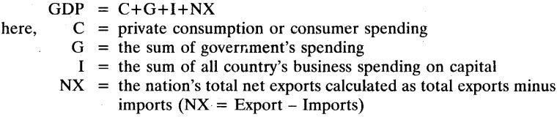

Ques 21. Compare the employment conditions prevailing in the organised and unorgan’ ised sector?
Ans:
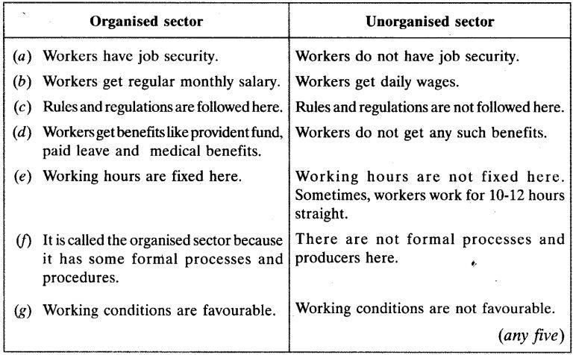

2013
Short Answer Type Ques [3 Marks]

Ques 22. Highlight the three factors responsible for the growth of service sector in the Indian economy.
Ans: Ever since the service sector got liberalized in the year 1991, it has seen constant growth. The following are the reasons responsible for the growth of service sector in the Indian economy.

- Increase in the income of people: Since the income level of the people has been increasing ever since, with increasing affluence there is increase in the demands of the services like maids, cooks, servants and gardeners. (h) Increase in population: With an

increase in number of people in the country, the demand for service sector has increased. Demands for service like schools, health department and nursing homes have increased.
- Increase in numbers of working women: With the passage of time there has been a massive increase in the number of working women in India. This has led to increasre in demands in the service sector like household help, babysitters and cooks.

Long Answer Type Ques [5 Marks]

Ques 23. Distinguish between public and private sectors. Ans:
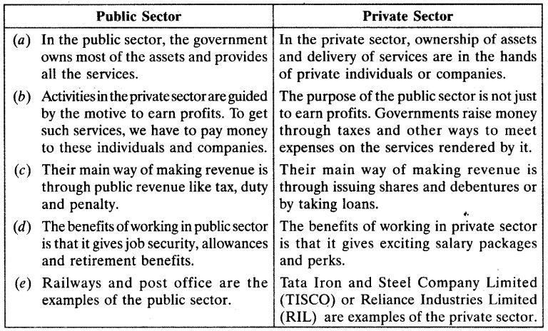

2012
Very Short Answer Type Questions [1 Mark]

Ques 24. Name the sector which forms the base for all other products. Ans: Primary sector forms the base for all other products

Ques 25. Name the sector in which natural products are changed into other forms. Ans: Natural products are changed into other forms in secondary sector.

Ques 26. Name the sector which helps in the development of primary and secondary sectors. Ans: Tertiary sector helps in the development of primary and secondary sectors.

Ques 27. Give four reasons for the rising of the tertiary sector in India.
Ans: Over the forty years, between 1970 and 71, and 2010 and 11, while production in all the

three sectors has increased, it has increased the most in the tertiary sector. The following factors are making the tertiary sector important in India.

- Basic services: In any country, several services such as hospitals, educational institutions, post and telegraph services, police stations, courts, village administrative offices, municipal corporations, defence, transport, banks and insurance companies, are required. These can be considered as basic services. In a developing country, the government has to take responsibility for the provision of these services.
- Development of primary and secondary sector: The development of agriculture and industry leads to the development of services such as transport, trade and storage. The greater the development of the primary and secondary sectors, the more would be the demand for such services.
- Rise in income levels: As income levels rise, certain sections of people start demanding many more services like eating out, tourism, shopping, private hospitals, private schools and professional training centres. We can see this change quite sharply in cities, especially in big cities.
- Rise in information technology: Over the past decade or so, certain new services, such as those based on information and communication technology have become important and essential. The production of these services has been rising rapidly.
- Globalization: Due to globalization, people have become aware of new services and activities, and communication because of which the tertiary sector has gained importance.

Short Answer Type Questions [3 Marks]

Ques 28. Why has the entire tertiary sector not grown in importance? Explain.
Ans: The entire tertiary sector has not grown in importance because of the following reasons:

- Peculiarity of skills in the tertiary sector: Highly-educated and skilled professionals only are able to get employment. Other engage themselves in low-paid jobs.
- High incomes: Higher incomes are available for the top-level administrative jobs only. Low-paid jobs do not attract employment.
- No job security: Large number of workers are casual with irregular and low incomes barely to sustain livelihoods.

Ques 29. Why does disguised employment not help in productivity of a country? Explain with the help of an example.
Ans: Disguised employment means that more number of people employed in an economic activity than required. If these extra people are removed, there will be no effect on the production. They seem to be employed but actually they are not. The workforce is not being used to its potential. They divide the work but do not increase production.
They do not help in increasing the productivity as their efforts are not economic. For example, in the rural areas, the entire family is engaged in the production of crops on the same piece of land. If there are ten people in the family, three people can manage the production. If the extra seven people ard removed the productivity will be the same. They seem to be making no contribution. Hence, it is truly stated that disguised or hidden employment does not help in productivity of a country.

Ques 30. Explain the meaning of disguised employment with the help of an example Ans: The following are the features of the unorganized sector.

- Working hours are more and harsh.
- No job security is there.
- No employment benefits are given.
- Employees work in poor working conditions.

2011
Short Answer Type Questions [3 Marks]

Ques 31. Explain the objectives of implementing the NREGA 2005
Ans: National Rural Employment Guarantee Act 2005 (NREGA) is an Indian labour law and social security measure that aims to guarantee the right to work.

- It aims at enhancing livelihood security in rural areas by providing at least 100 days of wage employment in a financial year to every household whose adult members volunteer to do unskilled manual work.
- The NREGA was initiated with the objective of “enhancing livelihood security in rural areas by providing at least 100 days of guaranteed wage employment in a financial year, to every household whose adult members volunteer to do unskilled manual work.”
- Another aim of NREGA is to provide employment within 5 km of an applicant’s residence, and minimum wages are to be paid. If work is not provided within 15 days of applying, applicants are entitled to an unemployment allowance.

Ques 32. Explain how public sector contributes to the economic development of nation. Ans:

- Creation of infrastructure: Public sector promotes the economic development since it brings about creation and expansion of infrastructure and the infrastructure plays an important role in economic development.
- Generates financial resources: Public Sector provides for various employment opportunities since major part of public sector depends on fhanpower and higher employment opportunities implies higher generation of financial resources for economic development.
- Contributes to HDI: Public sector majorly contributes to the Human Development Index since health and education industries come under the purview of public sector.
- Availability of goods: Public sector helps in availability of goods at moderate rates, which helps in maintaining financial security and thus helps in economic development.
- Provides encouragement: It provides encouragement to small, medium and cottage production units. It also strives for the creation of welfare state

Long Answer Type Ques [5 Marks]

Ques 33. In what ways can employment be increased in urban areas?
Ans: Urban unemployment is characterised by the existence of both open unemployment, which

in turn is an offshoot of rural unemployment itself, and the educated unemployment. Main causes of urban unemployment are insufficient economic development, defective system of education and slow growth of industrialisation.
Urban unemployment can be increased in the following ways.

- Reform of the educational system to make it vocational at the school stage.
- Concrete action will have to be taken to promote decentralisation and dispersal of industrial activity.
- Promotion of small-scale industries and encouragement to self-employment by banks.
- Develop techniques of production that can be taken up with low capital intensity.
- Provision of infrastructure like railways, roads, hospitals and schools which will not only create employment opportunities but also contribute to development.

2009
Short Answer Type Questions [3 Marks]

Ques 34. What is unorganized sector? Describe the working procedure of this sector.
Ans: An unorganized sector is a sector that is not registered by the government. It is characterized by small and scattered units. Being outside the control of the government, no rules and regulations are followed regarding the employment and working conditions.
This sector includes a large number of people who are employed on their own doing small jobs such selling things on the street or doing repair work. Working procedure in unorganized sectors is as follows.

- The unorganised sector is characterised by small and scattered units, which are largely outside the control of the government.
- There are rules and regulations but these are not followed.
- Jobs here are low-paid and often not regular.
- The condition of workers in unorganized sector is not good or stable.
- There is no provision for overtime, paid leave, holidays, leave due to sickness, etc.
- Employment is not secure. People can be asked to leave without any reason. When there is less work, such as during some seasons, some’people may be asked to leave.
- A lot also depend on the whims of the employer.
- This sector includes a large number of people who are employed on their own, doing small jobs such as selling things on the street or doing repair work

Ques 35. Explain with suitable examples which part of the service sector is not growing in importance.
Ans: The employment generation part of service sector is not growing in importance. The service sector in india employs different kinds of people. At one end, there are a limited number of services that employ highly skilled and educated workers.
At the other end, there are a very large number of workers engaged in services such as small shopkeepers, repair persons cattle, owners transport drivers and electricians. These people barely manage to earn there living and yet they perform these services because no alternative opportunity for work are available for them.

